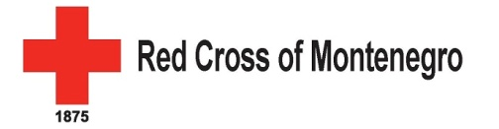
Assistance and protection to migrants

Red Cross of Montenegro as leading humanitarian organization in country has worked on different aspects when it comes to migration issue.
The context in Montenegro is different from other Balkan countries. The number of migrants in Montenegro is rather low but that doesn't ease the situation unfortunately because the people who come to Montenegro were returned from other European countries.
For last two years RCM has worked closely with international UN organizations (UNHCR, IOM ) in providing food and hygiene parcels for migrants, providing PSS and RFL assistance.
RCM conducts educational workshops within the Centre for asylum seekers on First aid, Human trafficking, RFL and general information on Montenegro. The RCM volunteers visit 2 times a week the Centre and spend time with children.
RCM has daily contact with relevant state institutions (Office for refugees, department of Ministry for Labour and Social Welfare and Office for asylum within Ministry of Interior).
RCM together with UNHCR and Legal center helps migrants when they leave the Centre for asylum seekers in finding apartments, bus tickets for children to go to school.
RCM helps also migrants with negative decisions for asylum to return to countries of origin or other safe countries providing clothes, food and hygiene and mediating with State institutions and IOM and embassies when necessary.
Currently RCM is looking for funding possibility in order to create CSO network which will work on protection of human rights of asylum seekers and lobbying for public policies.
Future activities: work with UNHCR and Office for refugees on Integration strategy for people with international and subsidiary protection (which will include education, labour, socialization) and also preparation of activities for implementation of new Law on people under international and subsidiary protection which will start to implement from January 2018.

